As our technological and sociological realities change, so too do our jobs. But just what, exactly, will we be doing 15 years from now? Here are some completely unexpected jobs you've almost certainly never heard of—but likely will soon.
Indeed, the landscape of careers is changing. But knowing which vocations are around the corner is not obvious. This is why the Canadian Scholarship Trust, as part of its Inspired Minds campaign, recently collaborated with the foresight experts at Idea Couture (a team that included scifi author Karl Schroeder). Together, they came up with 10 jobs that are likely to appear within the next 15 years or so, along with the skills and education required.
The end result is Careers 2030—an intriguing piece of speculative work designed to inspire conversations—between parents and kids, teachers and students, and so on—about what the world of work might look like in the near future. To learn more, we contacted Jayar LaFontaine, a Foresight Strategist at Idea Couture.

A Job Fair of the Future
"The aim of the project was not to make ironclad predictions about what kinds of jobs would be around in 2030," says LaFontaine. "It was more about starting conversations and broadening people's views of the possibilities." At the same time, however, LaFontaine says they wanted to make the jobs as plausible as possible while still being provocative and intriguing.
Related: 10 mindblowingly futuristic technologies that will appear by the 2030s

10 mindblowingly futuristic technologies that will appear by the 2030s
Two decades is not a lot in the grand scheme of things, but owing to accelerating change we can… Read more
"The way we anchored our discussion was by asking ourselves a few key questions," he told io9. "What's changing, and how fast? What kind of uncertainties does each element of change introduce into the picture? How big will the impacts be? And what will the changes mean for people on the ground?"
He asks us to consider the situation in Canada. Like many other economically developed countries, its population is aging. Consequently, its citizens will need to figure out the best ways to care for the elderly—and in ways that are both dignified and sustainable.
Other drivers of change that were considered by the team at Idea Couture included climate change, the changing energy economy, immigration, and the possible effects of new technology paradigms like wearables and smart objects.
Here are the 10 jobs they came up with.

Robot Counselor
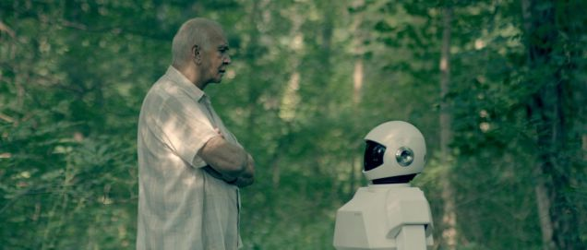Expand
"Let's get this sorted first: a robot counselor is not a psychoanalyst for your Roomba," he says. "Think of them as next-generation home installation experts and technology consultants. We imagined the market for home robotics in 2030 to be a crowded and robust space."
LaFontaine's team predicted that robots will perform a wide range of household duties, from cleaning to security to personal care and entertainment.
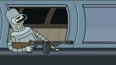

Who should pay when your robot breaks the law?
Robots are unquestioningly getting more sophisticated by the year, and as a result, are becoming an … Read more
"Purchasing a home robot might still be a significant investment in 2030, so making sure that you get the right robot for the job that won't be disruptive to your home life will be a fine balancing act," he says. "A robot counselor would observe how the family interacts and identify their needs so that they can make wise decisions about the types of robot assistants they might need. If a robot isn't fitting in, or if it is causing discord in the home, a robot counselor would be on hand to provide solutions and alternatives."

Rewilder
LaFontaine gives all the credit to Karl Schroeder for this one.
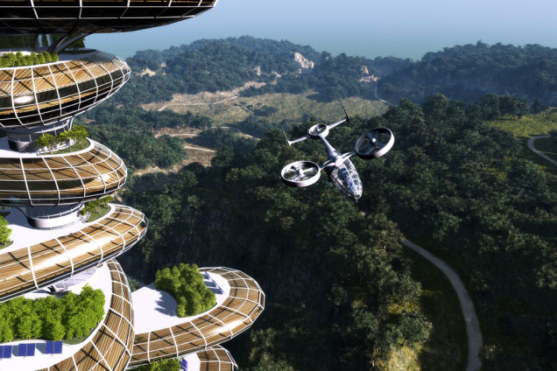Expand
"A rewilder's job is to help hasten the recovery process of natural habitats that have been decimated by human activity," he says. "The work of a rewilder would draw heavily on distributed sensor technology."
LaFontaine asks us to imagine laying down seed-sized sensors in an area to get a better sense of its health and determine what interventions might be appropriate.
"It might sound like a science fiction Johnny Appleseed scenario," he says, "but we've made real strides in developing sensor technologies for monitoring ecosystems and making useful inferences from that data."
Once a rewilder has a keen sense of the health of an ecosystem, they would set about implementing and monitoring interventions. They might remove human obstacles to animal migration paths or introduce native species or custom-designed micro-organisms in order to restore balance to the area's ecosystem.

Synthetic animals will save the planet
A recent project by designer Alexandra Daisy Ginsberg proposes that bioengineered creatures be… Read more

Garbage Designer
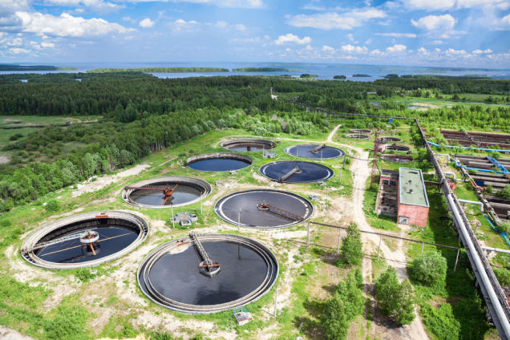34Expand
(Kekyalyaynen/Shutterstock)
The world's landfills are largely untapped gold mines—literally and figuratively, says LaFontaine. They contain large amounts of valuable metals, plastics, glass, and more. As Ramez Naam points out in his excellent book, The Infinite Resource, there may already be more aluminum in landfills than can be produced by the world's aluminum mines.
"A garbage designer is someone who taps into the value of trash in order to design valuable products," he says. "A great example that's around today is Freitag, a Swiss messenger bag manufacturer that makes its products out of repurposed truck tarps"
LaFontaine predicts that a garbage designer might work at the tail-end of product lifecycles, repurposing materials and creating new value in the form of new products. Or they may work with organizations to redesign their offerings in order to make them more easily upcycled by others.

Neighborhood Watch Specialist
LaFontaine admits that this idea might set people on edge a bit on account of the current alarmist conversation around drone technology.
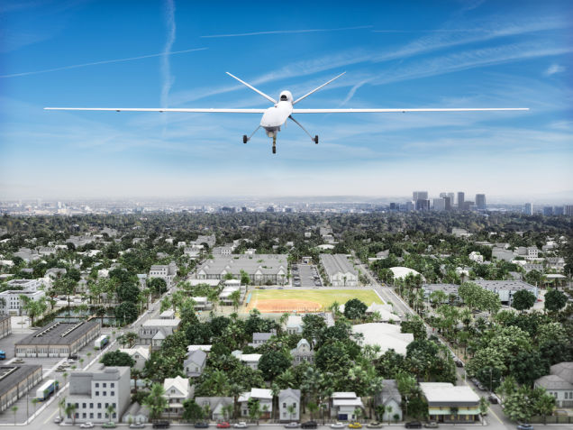56Expand
(Digital Storm/Shutterstock)
"We're kind of at the peak of inflated expectations when it comes to drone technologies, and most of what we anticipate is bad stuff," he says.
But drones might also do quite a lot of good, he says—from dispatching medical supplies to remote locations to delivering parcels and pizzas. He also predicts that drones will also likely become a powerful tool in the repertoire of journalists, both professional and civilian.
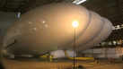

The world's largest aircraft has been unveiled -- and it's a mammoth
Who says our visions of a blimp-filled future are passé? Behold the Airlander, a hybrid air vehicle … Read more
"My first personal experience confirming drones had arrived was seeing a half dozen or so of them overhead at last year's Burning Man event [the banner image in this article was captured by a drone], documenting the spectacle," he adds. "Using drones to patrol neighborhoods is a deliberately provocative idea, but it may be a necessary countermeasure against those that use drones to case properties, for instance. A drone-equipped neighborhood watch specialists would need to be properly screened and accredited in order to create a relationship of trust in the community. These professionals would not only need squeaky clean records, they would also need security clearances and a keen understanding of both property laws and citizenship rights."

Simplicity Expert
The management paradigm of the 20th century was largely based on the factory model of industry. The representative organizational disciple of that era was Taylorism, a system that broke down the elements of human productivity into atomistic actions and then sought to find the most efficient means to complete a task, in terms of effort expended and time spent.
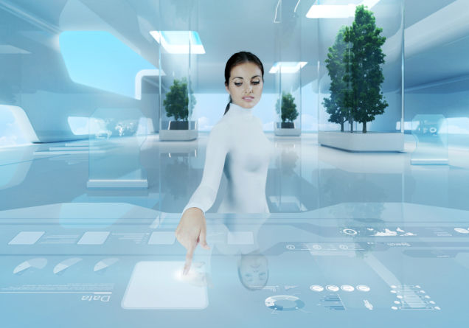7Expand
(sellingpix/Shutterstock)
"A simplicity expert is a bit like an organizational consultant, except instead of optimizing for efficiency —a practice that can leach the life out of an organization by making people feel like interchangeable cogs — they help organizations optimize for simplicity in their practices and environments," he says.
Simplicity experts have moved past Taylorism. If they have a patron saint, says LaFontaine, it's Mihaly Csikszentmihalyi, the Hungarian psychologist who has made a lifetime study of the way that humans achieve "flow" states, which are experiences of joyful and effortless mastery.
"Simplicity designers fuse together management science and cognitive and behavioral psychology to strike a balance between the goals of both organizations and the humans of which they are comprised."

Healthcare Navigator
There are healthcare navigators today, just not many of them. As William Gibson said, "The future is here, it's just not evenly distributed yet."

This Is How Wearable Computing Will Revolutionize Healthcare
Clinical settings and emergency rooms will never look the same once augmented reality and other… Read more
"Before becoming a futurist, I was part of a pilot project exploring the Healthcare Navigator role myself," LaFontaine told io9. "My job was to understanding the health system in Toronto and help individuals with traumatic brain injuries and their loved ones navigate its complexities. I also worked with a group of counterparts province-wide to share regional knowledge and figure out how we could best raise the profile of brain injury as a serious public health problem. As human systems becomes more and more complex, we think there'll be more work for individuals whose job it is to make them more navigable for people."

Nostalgist
Think of this one as a cross between an interior designer and a social worker—an idea that's driven by the growing awareness that the level of comfort felt in an environment has a real, measurable impact on health and wellbeing.
LaFontaine introduced me to the work of neuroscientists Maral Tajerian and Sebastian Alvarado who tested mice with nerve damage resulting in chronic pain in two environments. In their experiment, mice lived alone in cramped, bare cages, and others in large cages with toys, alongside other mice. After two months, the mice living in the enriched environment showed normal activity in the prefrontal cortex, while those living in the bare cages exhibited decline in cortical activity.
"Though mice are of course imperfect proxies for humans, this finding might have important implications for the way we design human environments," he says. "It suggests that some environments can predispose us to experience worse forms of chronic pain than we'd have otherwise."
It also means that the intensity of chronic pain can yield to environmental interventions, he adds.
Consequently, nostalgists could help elderly people design environments where they feel at ease, help with them activities of daily living, and be an empathetic social outlet for them. In countries with aging populations, LaFontaine says we should expect to see more services designed specifically to meet the needs of the elderly.

Telesurgeon
A telesurgeon operates on patients remotely via networked-connected robotic instruments.
Telesurgery is possible today, but the equipment is prohibitively expensive for small, remote communities where the technology could do the most good. In addition, telesurgery technologies require dedicated network links in order to mitigate the risk of poor communication links during a procedure; the last thing anyone wants is a buffering feed or other kind of error during an open heart telesurgery procedure.
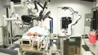

Robots aren't any better at performing surgery, they just cost more
Robots may be gaining an edge in package delivery, perhaps even telemarketing, but a new study says … Read more
"We imagined that improvements in robotics and network technologies would enable more hospitals to have access to telesurgery technologies," he says, "which could vastly improve access to specialized procedures in places like remote northern communities — and on space missions!"

Solar Technology Specialist
Solar technology is currently going through a kind of Moore's Law.
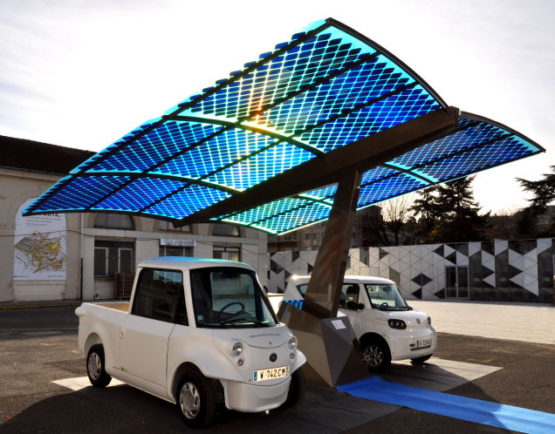Expand
(Tatmouss)
"Long down-played as the unreliable pet technology of idealists, both the price and performance of photovoltaic cell technologies have been improving year after year," he says. "In 1980, the price per watt of commercial solar modules was $22. Today, it is less at $1."
Indeed, solar is nearly or already competing at parity with non-renewables in markets around the world. So what might the solar market of the future look like?
"We can already see hints in universities, research labs and start ups around the world: solar breeders in the Sahara desert, cheap-to-produce thin films and stick-on cells, concentrated photovoltaics that rocket efficiency up to 41%, and solar capturing paints and glitters," he told io9. "By 2030, we imagined that there would be a robust job market for solar technology specialists. They may be 'solar farmers' that manage a large spread of solar grids and sell harvested power to stations and communities. Or they may work as consultants in urban spaces, helping building owners and managers to design, build, and maintaining solar energy systems."

Aquaponic Fish Farmer
Overfishing has been a serious problem in Canada for decades. Even more than twenty years after the federal government declared a moratorium on cod fishing in the northwest Atlantic, stocks of the fish have yet to make a full recovery. The loss of the cod fishing industry was a serious blow to Newfoundland, the maritime Canadian province that was hit hardest by the ban.
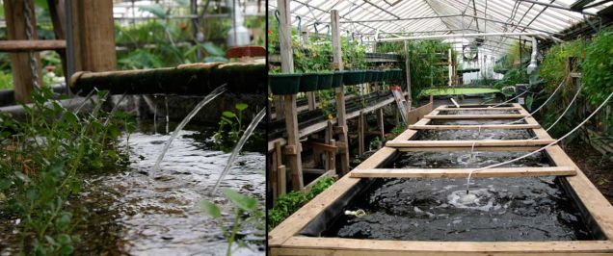Expand
(Growing Power)
The lesson, says LaFontaine, is that we should be wary of the pressure market demands put on natural resources and do our part to build systems that can meet demand sustainably; the consequences to both the environment and human communities are too great to ignore.
"One promising avenue for creating a sustainable market for fish aquaponics is the practice of creating a closed loop system that nurtures the grow both of fish stocks and vegetation," he says. "The 'wiring diagram' of aquaponics is actually quite simple: waste from fish is fed into a system containing nitrogen-fixing bacteria, which transforms it into nitrates and nitrites that can be used by plants as nutrients. The clean water is then recirculated back into fish tanks."
LaFontaine acknowledges that aquaponic farming is a centuries-old practice, but it may play a crucial role in creating sustainable food markets.
"Indoor aquaponics facilities can be built nearly anywhere, and so we expect that practice will be a popular way to eliminate 'food deserts' in both urban and rural environments by providing a healthy source for isolated or underserved communities."
Learn more about the Careers 2030 project here.

